**FINAL REPORT**

**Applied Capstone Project - The Battle of Neighbourhoods**

**Introduction:**

New York City's demographics show that it is a large and ethnically diverse metropolis. It is the largest city in the United States with a long history of international immigration. The New York region continues to be by far the leading metropolitan gateway for legal immigrants admitted into the United States. New York City has also been a major point of entry for immigrants; the term "melting pot" was coined to describe densely populated immigrant neighbourhoods on the Lower East Side. As many as 800 languages are spoken in New York, making it the most linguistically diverse city in the world. English remains the most widely spoken language in USA. English is least spoken in neighbourhoods such as Flushing, Sunset Park, and Corona. With its diverse culture, comes diverse food items. There are many restaurants in New York City, each belonging to different categories like Chinese, Indian, and French etc. In USA, there are number of Indians are living and provided with the number of Indian restaurants.

**Problem:**

To find the answers to the following questions:

Q1) List and visualize all major parts of New York City that has great Indian restaurants.

Q2) what is best location in New York City for Indian Cuisine?

Q3) which areas have potential Indian Restaurant Market?

Q4) which all areas lack Indian Restaurants?

Q5) which is the best place to stay if you prefer Indian Cuisine?

**Data Section:**

New York City is a large and ethnically diverse metropolis. With its diverse culture, comes diverse food items. There are number of restaurants in New York City, also there are different types of food item with yummy taste, each belonging to different categories like Chinese, Indian, and French and many more. So to do this project we need some important data.

The required data for this project is:

**Data source :** https://cocl.us/new_york_dataset

**Description:** This data set contains the required information which will be used to explore various neighbourhoods of New York City

**Indian restaurants in each neighbourhood of New York City.**

**Data source :** Foursquare API

**Description:** The Foursquare API will provide us each venue in different neighbourhoods.

**GeoSpace data**

**Data source :** https://data.cityofnewyork.us/City-Government/BoroughBoundaries/tqmj-j8zm

**Description:** The geo space will help us to visualize choropleth map.

**Methodology:**

1. First collect the New York city data: "[https://cocl.us/new_york_dataset"](https://cocl.us/new_york_dataset%22)
2. Use Foursquare API to find the venues

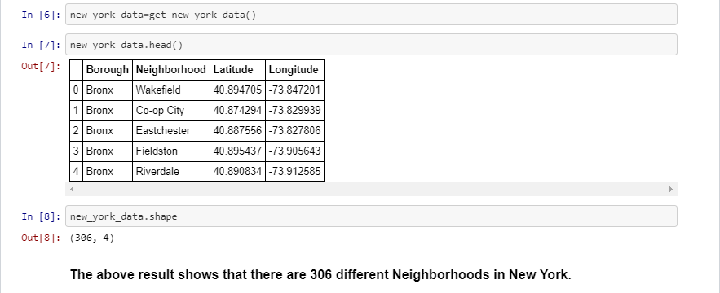

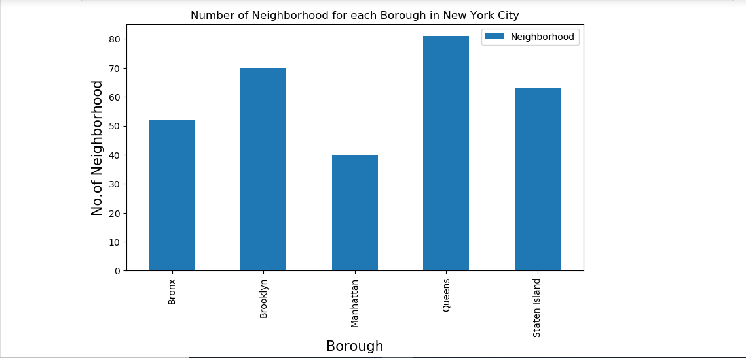

1. 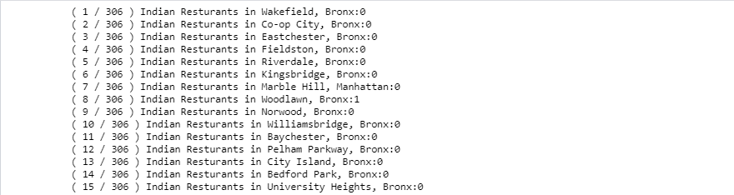 then filter out all venues with Indian restaurant for further analysis.

1. Then use Foursquare API to find the Ratings, Tips, and Number of Likes for all the Indian Restaurants.

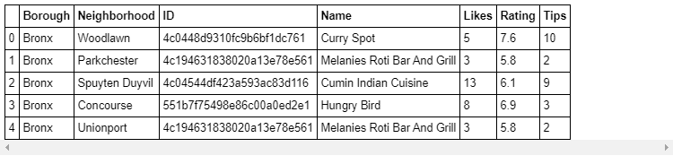

1. Sort Neighbourhoods and Borough the data keeping Ratings as the constraint.

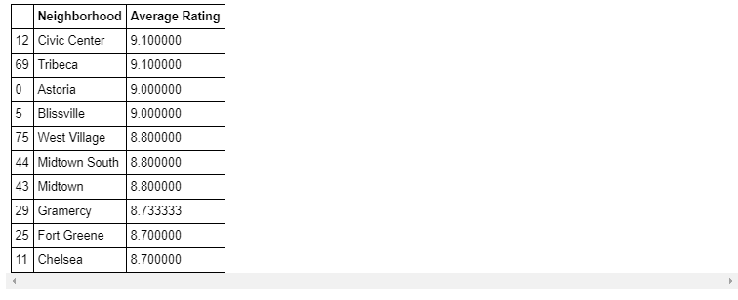

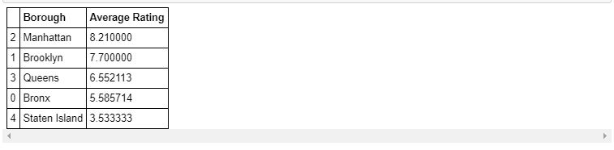

1. Next we will consider all the neighbourhoods with average rating greater or equal 9.0 to visualize on map.

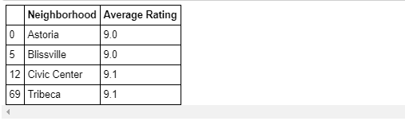

1. Join this dataset to original New York data to get longitude and latitude.

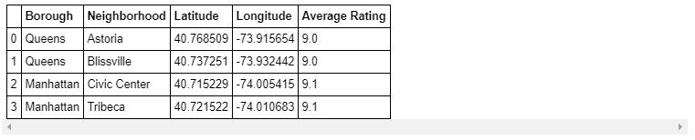

1. Finally, visualize the Neighbourhoods and Borough based on average Rating using python’s Folium library.

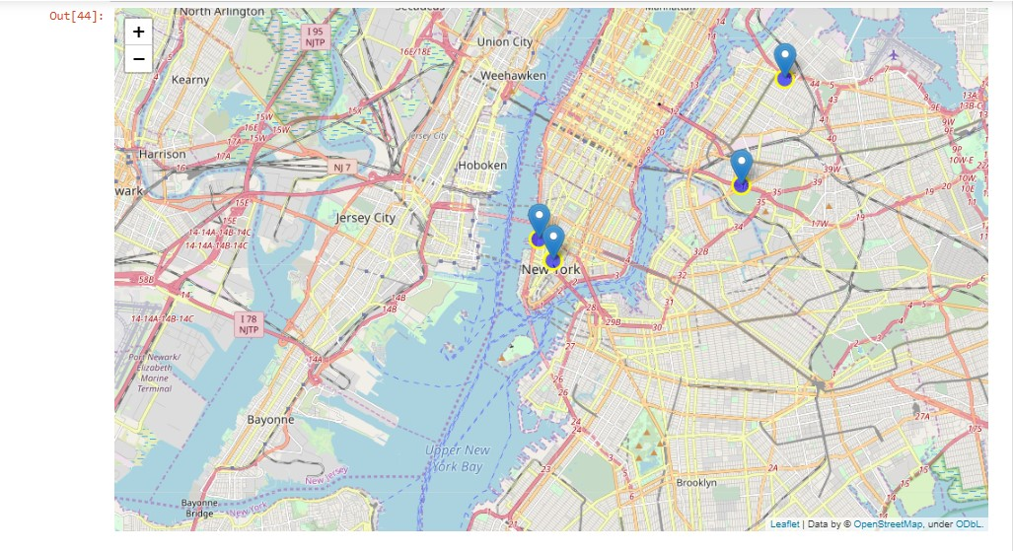Neighbourhoods based on average rating:

Borough based on average rating:

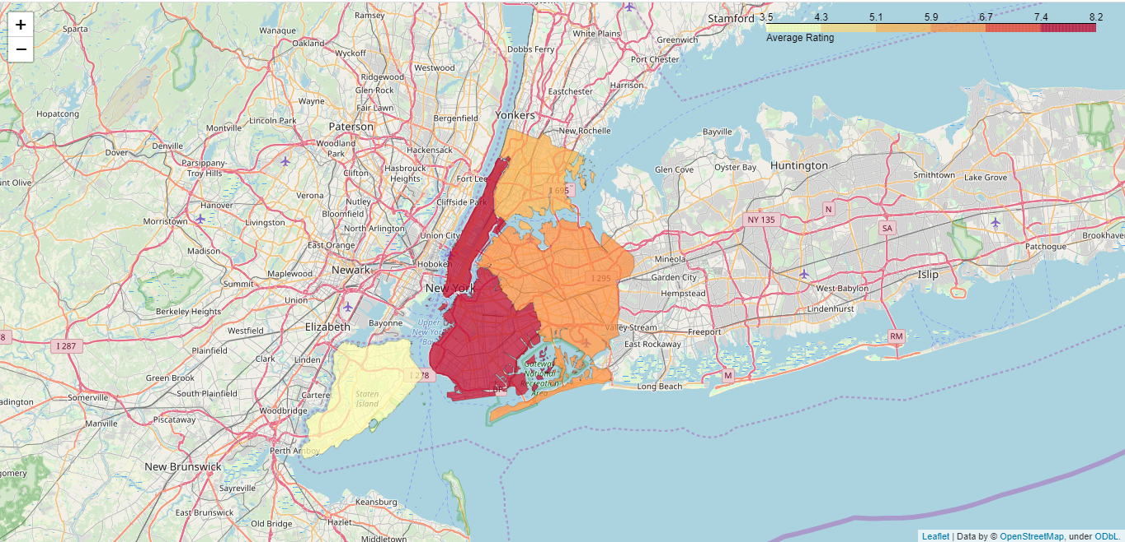

**Result:**

So now we can answer the questions asked above in the Questions section:

Answers:

1. The following location in New York City has great Indian restaurants.



#### Astoria (Queens), Blissville (Queens), Civic Center (Manhattan) are some of the best neighbourhoods for Indian cuisine.

#### Manhattan have potential Indian Restaurant Market.

#### Staten Island ranks last in average rating of Indian Restaurants.

#### Manhattan is the best place to stay if you prefer Indian Cuisine.

**Conclusion:**

There is always room for improvement and hence the above solution I have provided can also be improved for best results depending upon the data we have.